Game Journal:

Day 1 (11/4):

Goals:
Today I would like to implement a resetting feature that removes all enemies on screen after the player dies, probably using an array list. I would also like to have a starting screen and revert to the starting screen if the player dies.

Progress:
I was successful in adding the resetting feature that removes all enemies on screen, but I was unable to make a starting screen. I also tried to make a player class, but it didn’t work. I also started to implement a color change feature (change to red) but we ran out of time.

Day 2 (11/6):

Goals:
Today I would like to implement the starting screen that I wanted to implement last time, and I would like to fully implement the color change feature that I started last time.

Progress:
I finished adding the color change function and the size change function for when the character is hit which made the game more interesting. I somewhat implemented the start screen, but it isn’t done yet. It looks like this:
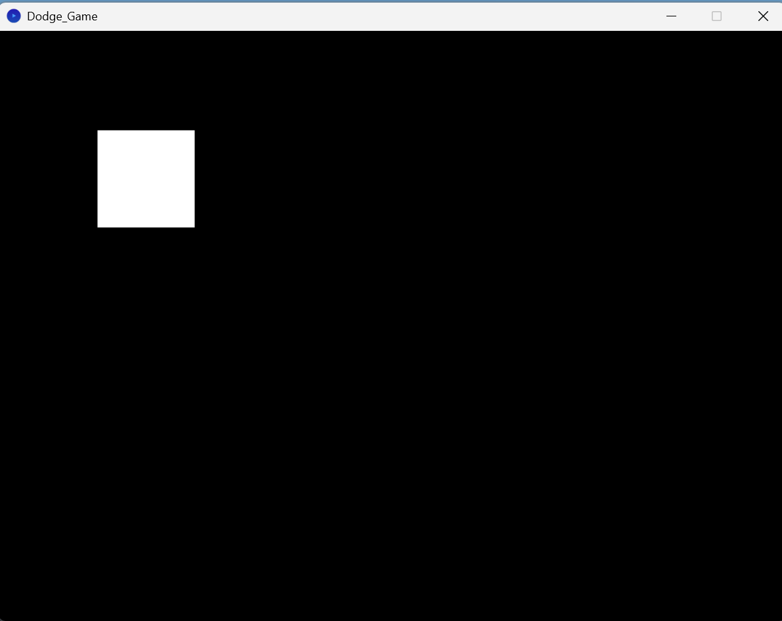

Extra:
Over the weekend I worked on adding a font, improving the start screen, and making the game automatically restart when you die by using a function to rerun the initial draw functions and reset the variables.

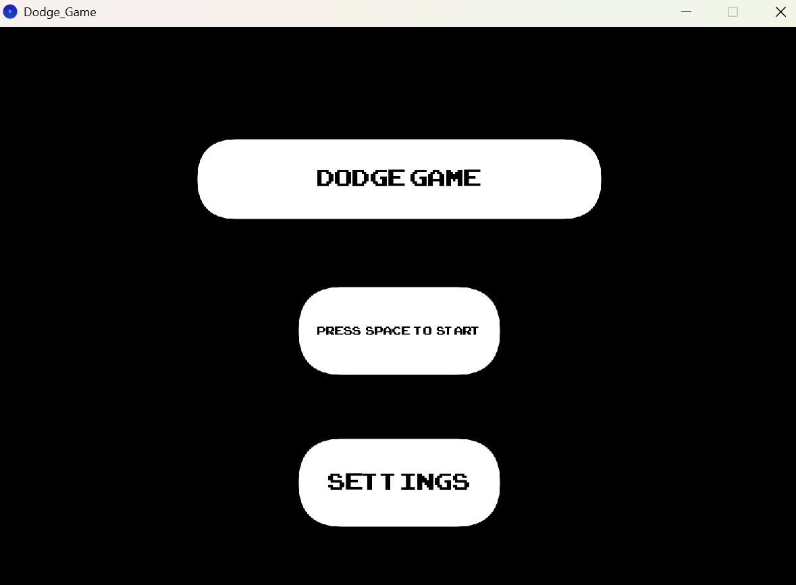

Day 3 (11/10):

Goals:
Today I would like to add functionality to the start screen, hopefully adding press-able buttons and customization features. If I can’t figure that out I would like to add difficulty increases and optimization.

Progress:
I was unable to make press-able buttons today and no customization features. But I was able to add a color changing function when the mouse hovers over the boxes. Here is what it looks like:

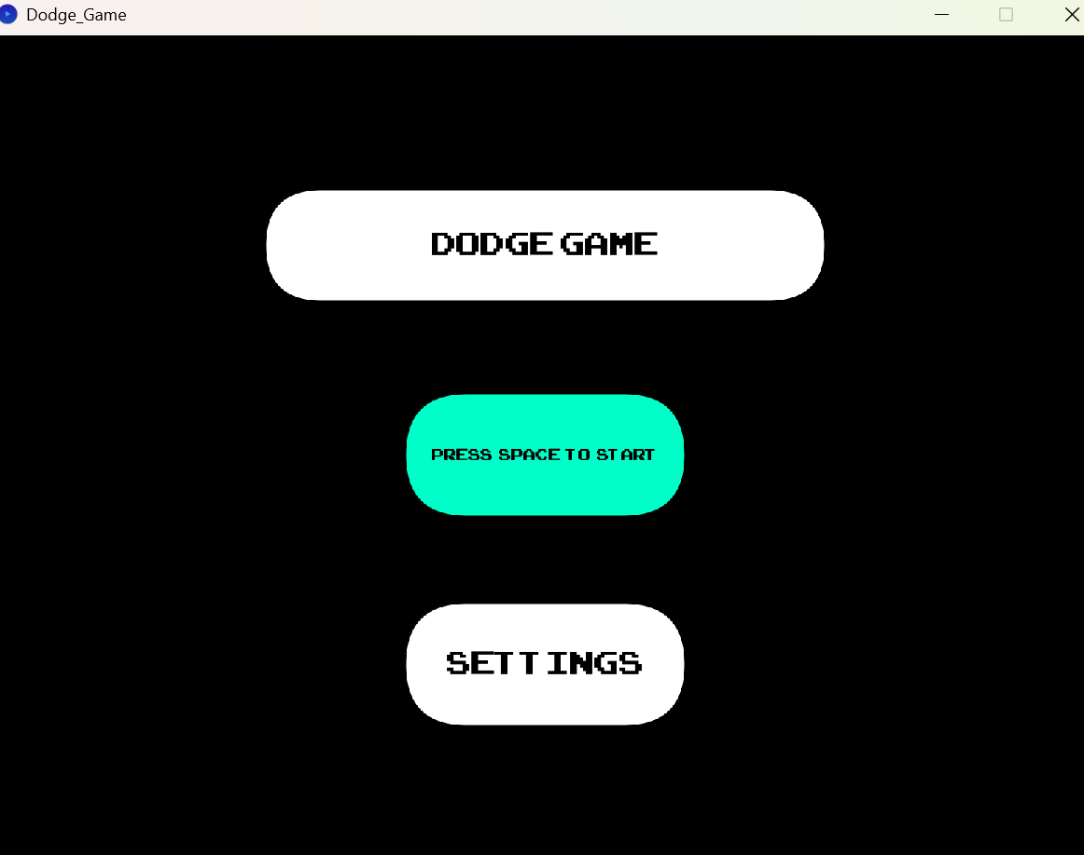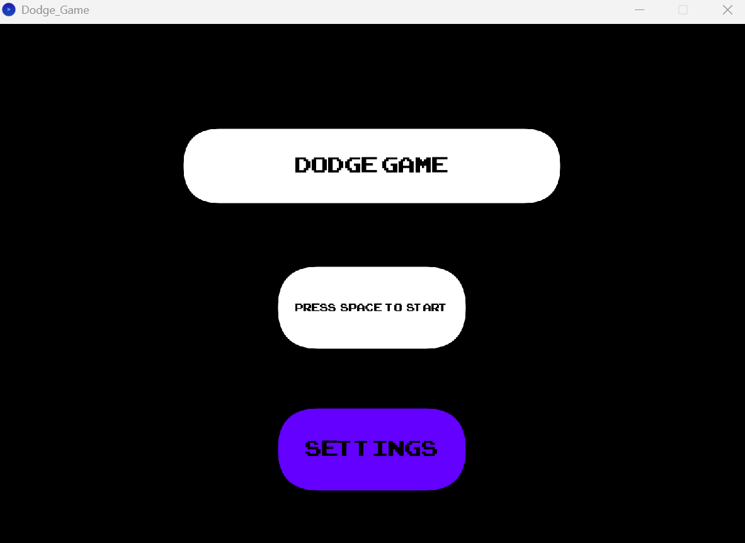

Day 4 (11/12):

Goals:
Today I would like to add a settings screen for customization features that opens when the settings button is clicked.

Progress:
Today I was able to create a fully functional settings screen that you can click into… but it does not have any changeable settings yet, just a functional extra screen that you can access and exit. A little thing I added with extra time was arrow key functionality so now my game can be played with both wasd and updownleftright arrows.
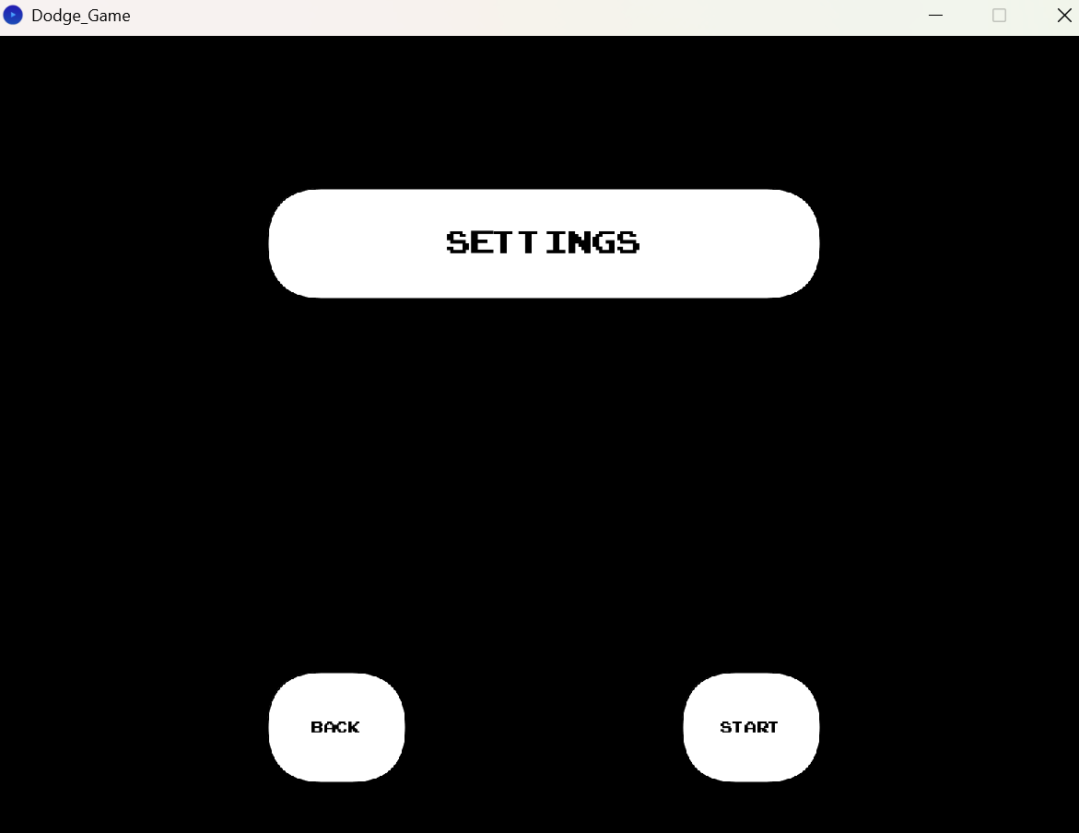

Day 5 (11/18):

Goals:
Today I would like to add a button in settings that changes the gameplay. Specifically, a button that would increase the speed and amount of circles.

Progress:
Today I was able to both make two difficulty settings buttons, but they have no functionality except for easy mode button staying green permanently after you click it to show that you have activated easy mode (gonna add that to hard mode button and also make them unable to be active at the same time and an overall settings resetting button at the bottom of settings screen in between start and back). I was also able to eliminate a bug where you could activate start by pressing a random spot on the settings screen.
